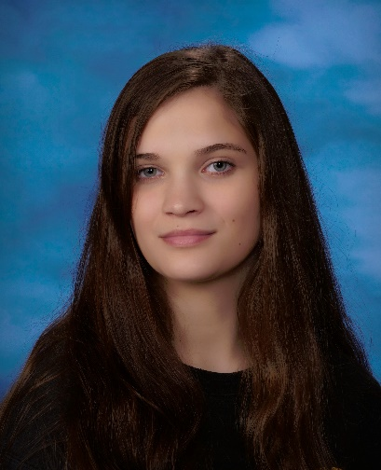

# Education

Vinal Technical High School, Middletown, CT

Diploma Expected in 2025

## Professional experience

**After School Care Staff**

Haddam-Killingworth Recreation | Sept 2024 – Present

* Supervised and engaged children in activities, ensuring a safe environment.
* Developed communication and time management skills.
* Adapted to dynamic situations and solved problems efficiently.

#### **Certifications**

#### Agile Project Management

#### Google Project Management

#### Project Execution: Running the Project

#### Foundations of Project Management

#### Project Initiation: Starting a Successful Project

#### Project Planning: Putting It All Together

#### Step Ladder Safety Training

#### My Career Tech Customer Service

#### Microsoft Office Specialist: Excel

#### PC Pro

#### IT Fundamentals Pro

**Volunteer Work**

* Vinal Tech Blood Drive Volunteer – Assisted with event coordination, donor support, and logistics.
* Open House Volunteer – Helped with setup, guidance, and event facilitation.
* Career Fair Volunteer – Assisted in setup, cleanup, and attendee support.
* Higganum Methodist Church Volunteer – Contributed to community events and activities.
* Tech Help at Senior Center – Provided technology assistance to seniors, improving digital literacy.

**Honors &**

**Achievements**

2024-2025 (Grade 12)

-Q1 Honor Roll – High Honors

- Q2 Honor Roll – High Honors

- 2023-2024 (Grade 11)

- Q1 Honor Roll – High Honors

- Q2 Honor Roll – High Honors

- Q3 Honor Roll – High Honors

- Q4 Honor Roll – High Honors

- 2022-2023 (Grade 10)

- Q1 Honor Roll – High Honors

- Q3 Honor Roll – High Honors

- Q4 Honor Roll – High Honors

- 2021-2022 (Grade 9)

- Q1 Honor Roll – Honors

# Contact

860-990-1900

ermeyer198@gmail.com

Higganum, CT, USA

https://www.linkedin.com/in/elizabet-m-65a7b1329/

Elizabet Meyer

Website Designer